**IST 659 – M002 – Fall 2018 Lab 1**

**Business Rule 1:** *Each company hires at least one employee; and an employee cannot work for more than one company. Each company must have at least one project; a project must be organized by at least one company. An employee may or may not work in several projects; each project must have at least one employee.*

***ER Diagram***

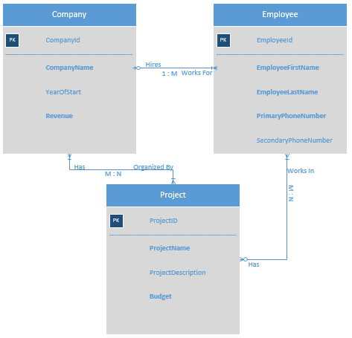

*Entities:*

1. *Company:*

*Attributes: a)* ***CompanyId*** *(Primary Key)*

*b)* ***CompanyName*** *(Required)*

*c) YearOfStart (Optional)*

*d)* ***Revenue*** *(Required)*

1. *Employee:*

*Attributes: a)* ***EmployeeId*** *(Primary Key)*

*b)* ***EmployeeFirstName*** *(Required)*

*c)* ***EmployeeLastName*** *(Required)*

*d)* ***PrimaryPhoneNumber*** *(Required)*

*e) SecondaryPhoneNumber (Optional)*

1. *Project:*

*Attributes: a)* ***ProjectId*** *(Primary Key)*

*b)* ***ProjectName*** *(Required)*

*c) ProjectDescription (optional)*

*d)* ***Budget*** *(Required)*

*Additional Business Rules:*

*Not Applicable*

**Business Rule 2:** Each owner owns at least one shop; and a shop must have only one owner. Each owner may or may not hire several staffs; each staff must work for only one owner. Each shop may or may not contain several staffs; each staff must work at only one shop. ***one-to-many relationship***

***ER Diagram***

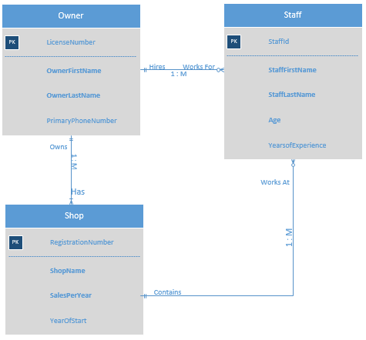

Assumptions: In certain shops, the owner works without any staff.

*Entities:*

1. *Owner:*

*Attributes: a)* ***LicenseNumber*** *(Primary Key)*

*b)* ***OwnerFirstName*** *(Required)*

*c)* ***OwnerLastName*** *(Required)*

*d) PrimaryPhoneNumber (Optional)*

1. *Staff:*

*Attributes: a)* ***StaffId*** *(Primary Key)*

*b)* ***StaffFirstName*** *(Required)*

*c)* ***StaffLastName*** *(Required)*

*d)* ***Age*** *(Required)*

*e) YearsOfExperience (Optional)*

1. *Shop:*

*Attributes: a)* ***RegistrationNumber*** *(Primary Key)*

*b)* ***ShopName*** *(Required)*

*c)* ***StaffLastName*** *(Required)*

*d)* ***SalesPerYear*** *(Required)*

*e) YearOfStart (Optional)*

*Additional Business Rules: Each staff working at a shop must be 18 years or above.*